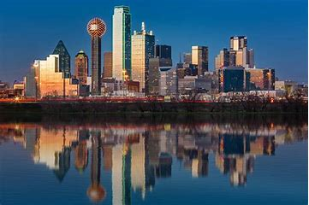  Briggs-Salmond Family Reunion – Registration Form  Friday, May 26, 2023 -  Sunday, May 28, 2023  Embassy Suites Hotel and Conference Center  7600 John Q. Hammonds Drive  Frisco, Texas 75034  972-712-7200  Adult #1______________________________$160 - Paid_____  Adult #2______________________________$160 - Paid_____  Adult#3______________________________ $160 - Paid_____  Adult#4______________________________ $160 - Paid_____  Adult #5______________________________$160 - Paid_____  Adult #6______________________________$160 - Paid_____  Child #1______________________________ $100 - Paid_____  Child #2______________________________ $100 - Paid_____  Child #3______________________________ $100 - Paid_____  Child #4______________________________ $100 - Paid_____  Total in Attendance_______ Total Fee Paid_________  Name_____________________Phone Number______________ | T-Shirt Order Form  This form due by  April 1, 2023  Adult Sizes and Prices  XXXL - $22 – Qty__________  XXL – $22 – Qty__________  XL – $20 – Qty_________  Large - $20 Qty__________  Med. - $20 Qty_______  Small - $20 – Qty__________  Kids Sizes and Prices  Sizes 9 – 16 - $15  Size_______Qty______  Size_______Qty______  Size_______Qty_____  Size_______Qty_______  Infant to Kids Size 8 - $10  Size_________Qty_______  Size________ Qty________  Size______ Qty__________  Size________ Qty________  Qty Total___________  Total $ Due____________  Briggsdadw4@sbcglobal.net

